**PROJECT TITLE :-** Intelligent Fault Diagnosis

**ABSTRACT :-**

Ball bearings faults are one of the main causes of the breakdown of rotating machines. Thus, detection and diagnosis of mechanical faults in ball bearings are very crucial for reliable operation. This study focuses on the classification of faulty bearing using Machine Learning Techniques. A test rig of a high-speed rotor supported on rolling bearings will be used. The vibration response will be obtained(acceleration vs time) and analyzed knowing beforehand whether the bearing undergoing the test is faulty or healthy(i.e. supervised learning). Statistical methods will be employed to extract features from the collected data and then will be implemented in the chosen learning model. Attempts will be made to achieve optimum accuracy by either deploying a new learning model or changing features. Thus, algorithms for hyperparameter Optimization will be used to select optimum features. The selected model then will be tested and evaluated on the basis of data further collected from the test rig with different bearings. Maximum accuracy will be attempted to be approached at last. If Binary classification works sound, attempts will be made to make a multi-classification classifier.

**TIMELINE :-**

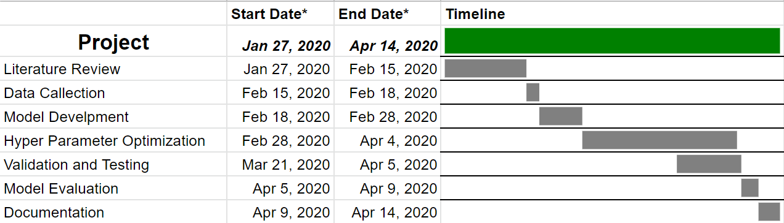

**TEAM MEMBERS :- SUPERVISOR**

17117048 - Mridul Agrawal ***(TEAM LEADER)*** Prof. S. P. Harsha

17117033 - Harshil Kumar Patel

17117077 - Saurabh Kurmi

17117080 - Subhram Subhrajyoti Rana